How to use on-line access
Click on the On-line access tab
Click here to access System Online
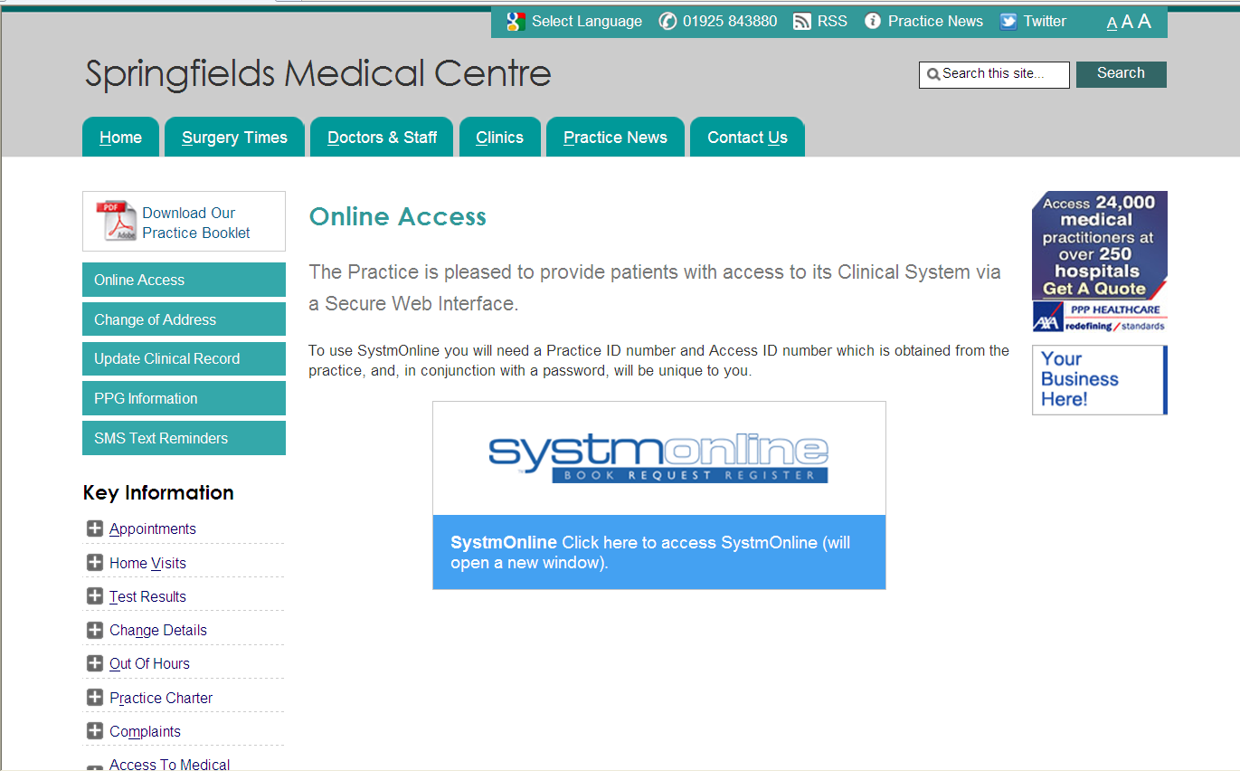

You will be directed to the following screen where you need to enter your username and password supplied to you by the surgery (if you have forgotten your password please telephone the surgery on 01925 843880)
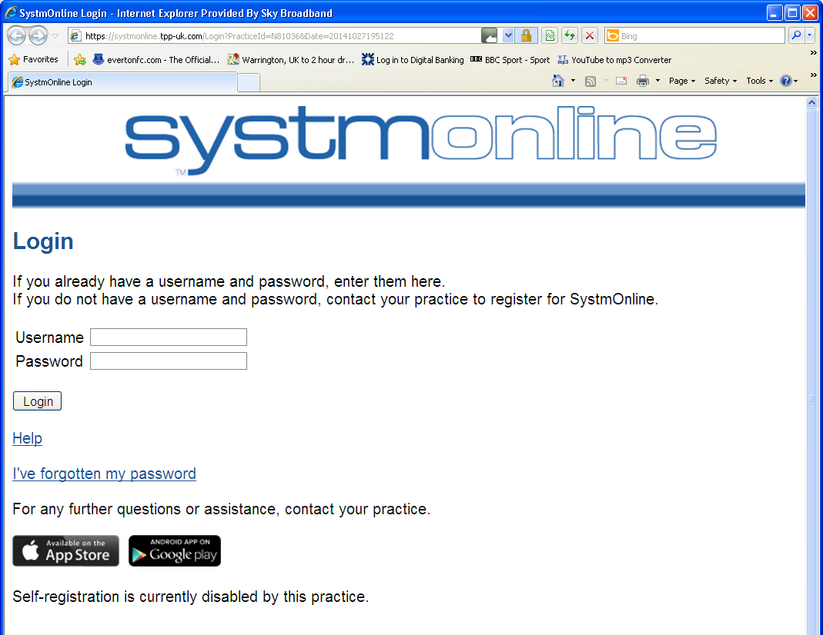

Once logged in you will see a list of options on the left hand side of the screen

HOME

- Appointments
- Medication
- Patient Record
- Messages
- Questionnaires
- On-line Account Management
- Help
- Logout

To request your REPEAT medication click on MEDICATION, under the heading MEDICATION, select MEDICATION
A list of your repeat medication will appear
Tick the box next to the medication you require and press the REQUEST MEDICATION button
If you find the tick box unavailable as below this is because your GP needs to review your medication.

IF SOME OF YOUR REPEAT MEDICATION HAS NOT GOT A TICK BOX NEXT TO IT AS BELOW YOU WILL NEED TO SELECT “MAKE CUSTOM REQUEST” AND TYPE THE MEDICATIONS YOU REQUIRE IN THE BOX UNDER MEDICATION REQUEST NOTES. SELECT “REQUEST MEDICATION”

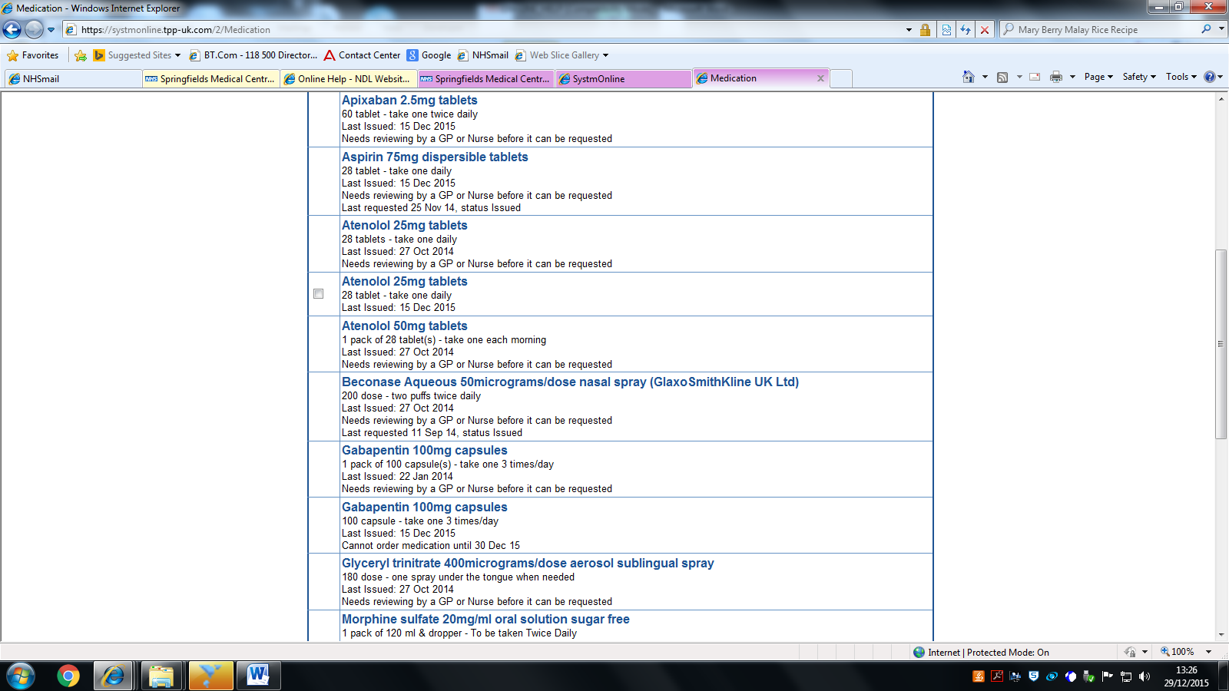

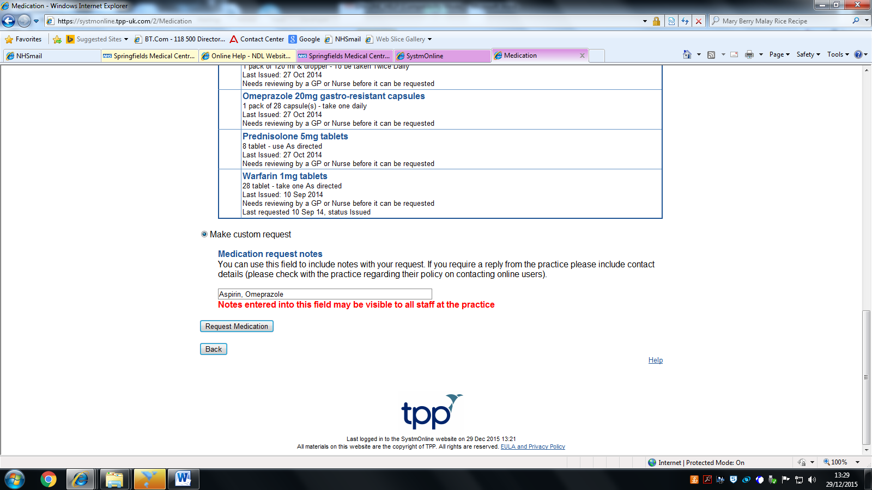

To request an ACUTE medication (an item which is not on your repeat medication screen)
click on MEDICATION, under the heading MEDICATION, select MEDICATION
click on MAKE CUSTOM REQUEST and type in the item(s) you require and select REQUEST MEDICATION

