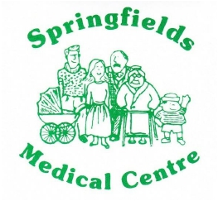
Springfields PPG Newsletter

Number 17 – September 2017

Chairman Mr Peter Wilson

Website- www.springfieldsppg.co.uk

Introducing our Medical Staff at Springfields Medical Centre

Dr Neetika Aggarwal
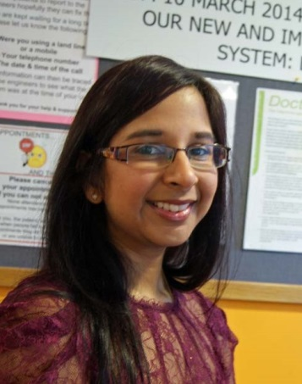

I joined Springfields Medical Centre in 2010 following completion of my GP training in Salford. I originally completed my Medical Degree at University of Manchester.
I have completed the Diploma in the Primary Care Management of Diabetes and subsequently with the support of the Practice nurses look after the Diabetic Patients.
I completed a diploma in Obstetrics and Gynecology during my GP training and also have an interest in Women's Health.
I also have an interest in teaching and training and I currently supervise the Foundation Year 2 Doctors who come from the hospital on 4 monthly Rotations to gain experience in General Practice.

Dr Flora Kyriakou
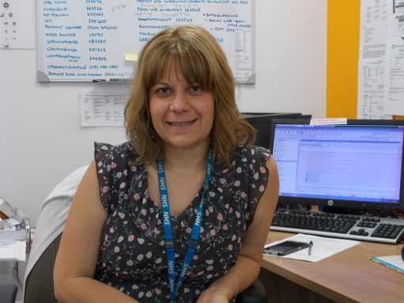
I joined the Practice in May 2015. I was born and raised in Athens, Greece and have lived in the UK since 2003.
I completed my GP vocational training in 2014 in the Mersey Deanery. I worked as a sessional GP in Liverpool for the first few months after I qualified and I worked as a salaried GP for a brief period in Warrington before joining Springfields Medical Centre.
I have a special interest in dermatology and I have recently completed a 3 month course “Introduction to Dermoscopy” from Cardiff University. I am hoping to expand my practical skills more and a future plan would be to set up also a Minor Surgery Clinic.
I carry out the six week baby checks.
I am fluent in Greek and also fluent in Romanian and German
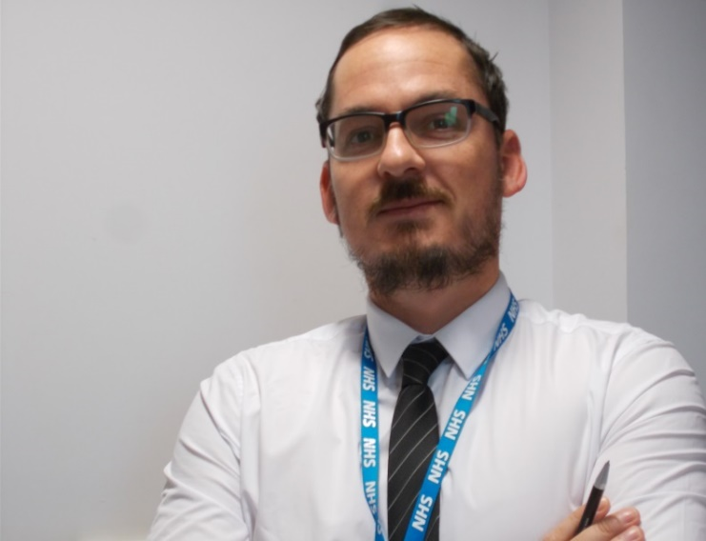
Dr Gareth Cox
I joined the Practice in October 2016.
I was born in Warrington. I completed my medical training at Liverpool University. After this I worked in Southport Hospital for 3 years, it was here I decided my love was for General Practice, which saw me move back to Warrington to work as a GP in Stockton Heath.
I have now worked in General Practice for 10 years. Over the years I have developed interests in both care of the elderly and musculoskeletal/sports medicine. I also have an interest in men’s health. I carry out the six week baby checks
Outside of work I have a busy family life with two young children and 3 black Labradors.
I am a lifelong Manchester United supporter and enjoy following the ups and downs of the Warrington Wolves. I have also been known to play tennis and golf when allowed!

Mr Mehrad Hosseini – Clinical Pharmacist
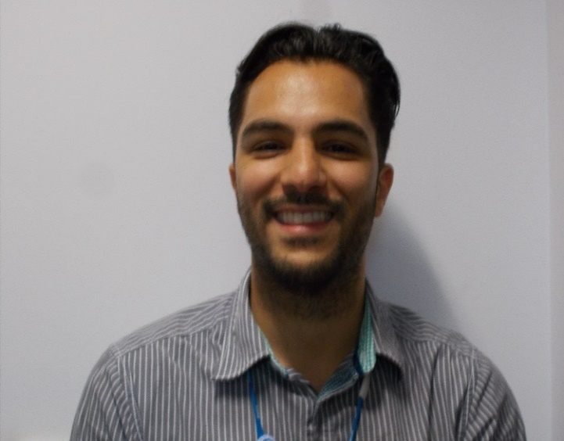
Graduated from University of Bradford in 2010 and completed a Post Graduate Hospital Clinical Diploma in 2014. Worked in hospital pharmacy for over 5 years and rotated through various specialties including General Medicines, Renal, Cardiovascular, General Surgery and medicines information.

As Mehrad’s role is new to the practice we thought it would be good to ask him some questions regarding his role at Springfields
- Why should we the patients have a consultation with you? – I am able to spend more time with patients. Consultation is more medication centred and will help patients understand what their medication is for and if they are taking it correctly

- Are you fully qualified? – Yes. Training as a Pharmacist takes 5 years, I have an M Pharm degree. I also did 2 years post qualification which is a more clinical diploma

- Why should we see you instead of the Doctor? – As indicated in question 1, I am able to spend more time with patients than a GP and if your query is relating to medication, due to my training I am in a better position to advise you. You also then have a point of contact for future medication queries

- Will you discuss with the GP my individual case? Yes If I need to discuss to your case with your GP

- If I agree to see you can I also see the Doctor? Yes

- Can you prescribe medication? I am unable to prescribe medication until I have completed my prescribing course in February 2018 but if you require a prescription I can organise this for you and have it signed by a GP

- Can you write up my prescriptions / change them? Yes GPs often forward hospital letters and discharge summaries to me which have medication changes on

- When can I see you and how do I make an appointment? I work every Tuesday afternoon and Wednesday morning. To arrange either a telephone consultation or face to face appointment please telephone reception and ask to see/speak to the Clinical Pharmacist. The Receptionist will ask you for a brief description of the problem
- How long will an appointment last? This depends entirely on the query, I will give you as long as you need

- Will your advice and recommendations be added to my records? Yes

- Do I have to pay to see you? No

- Will you follow up my case and monitor results? Yes

- When are you available for consultation? Tuesday afternoon and Wednesday morning

- If discharged from hospital will you be able to assess any medication proposed and advice? Yes

- Is it intended for this service that you provide to be a supplement to that given by the Doctors? Yes.

- Are you an alternative to seeing the Doctor? This depends on the problem. I can deal with medication queries, medication following discharge from Hospital, advice on side effects, general advice on urine infections, sunburn, head lice, common coughs and colds, diarrhoea and vomiting, indigestio

