WE DID IT!
On Saturday 20 June the GPs and staff took park in Pretty Muddy a 5k fun run at Tatton Park Cheshire in aid of Cancer Research UK.
Thanks to your generosity we have raised in excess of £2055

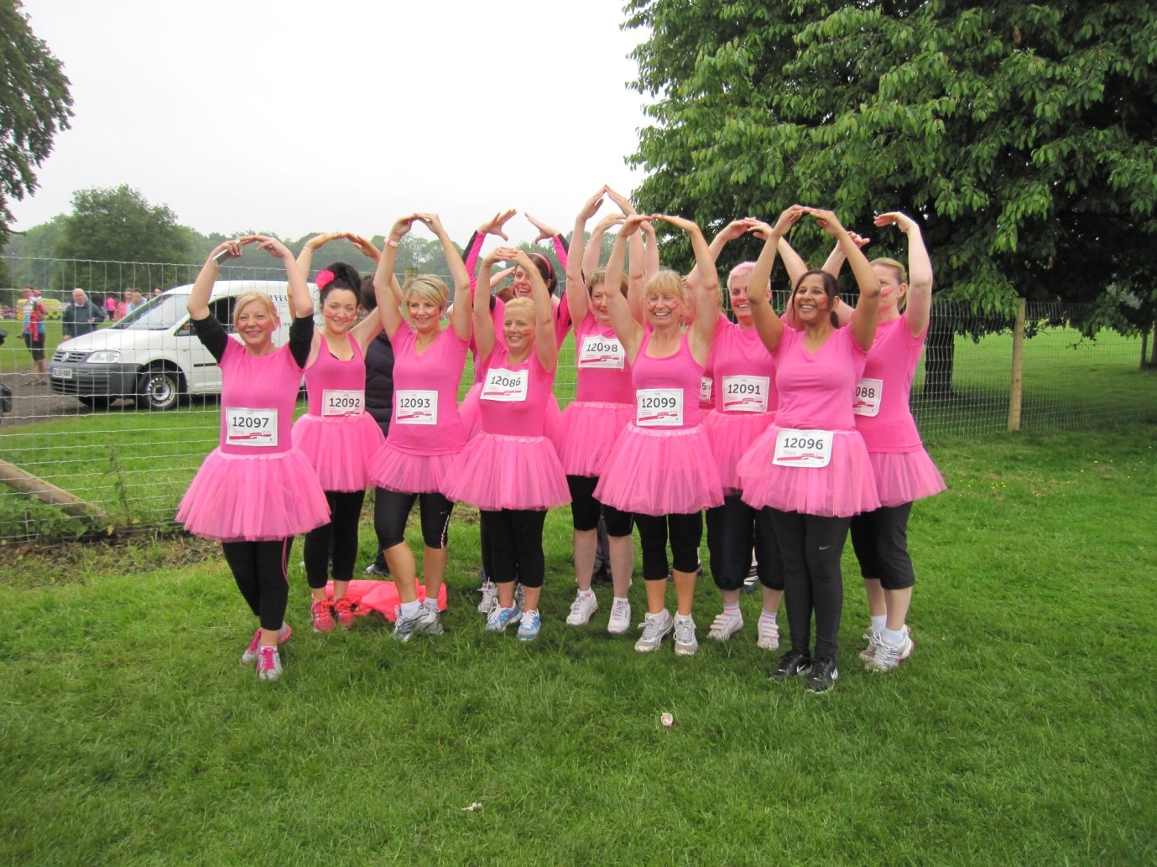
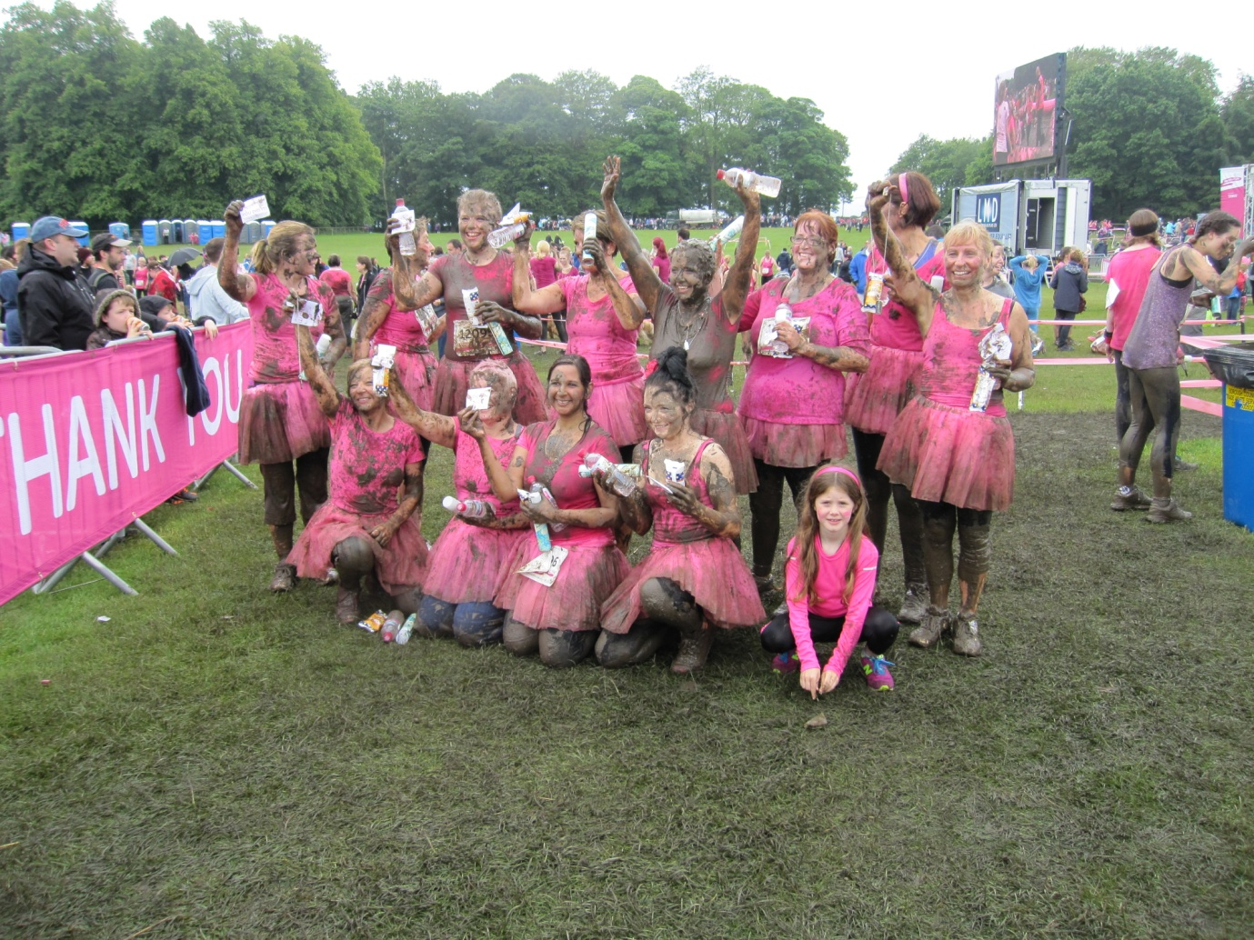

THANK YOU TO EVERYONE WHO DONATED

