How to use on-line access
Click on the On-line access tab
Click here to access System Online
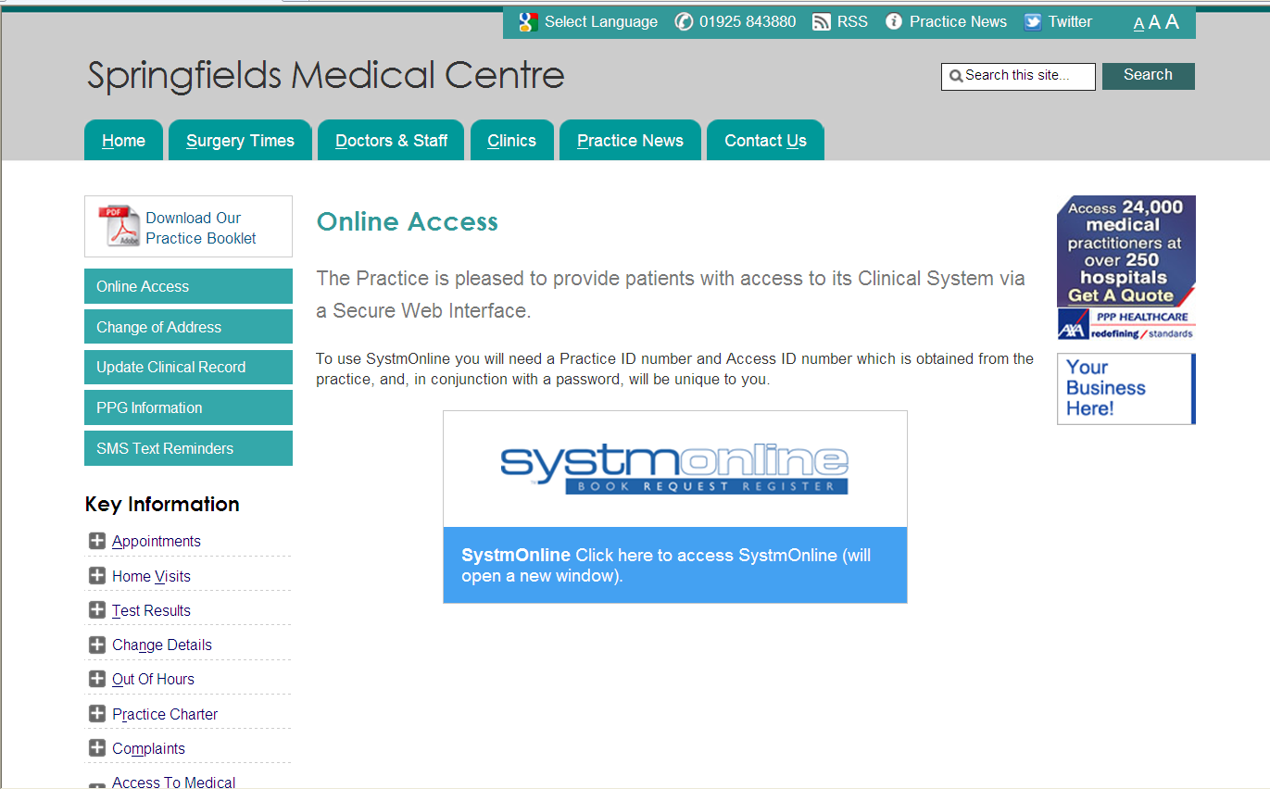

You will be directed to the following screen where you need to enter your username and password supplied to you by the surgery (if you have forgotten your password please telephone the surgery on 01925 843880)
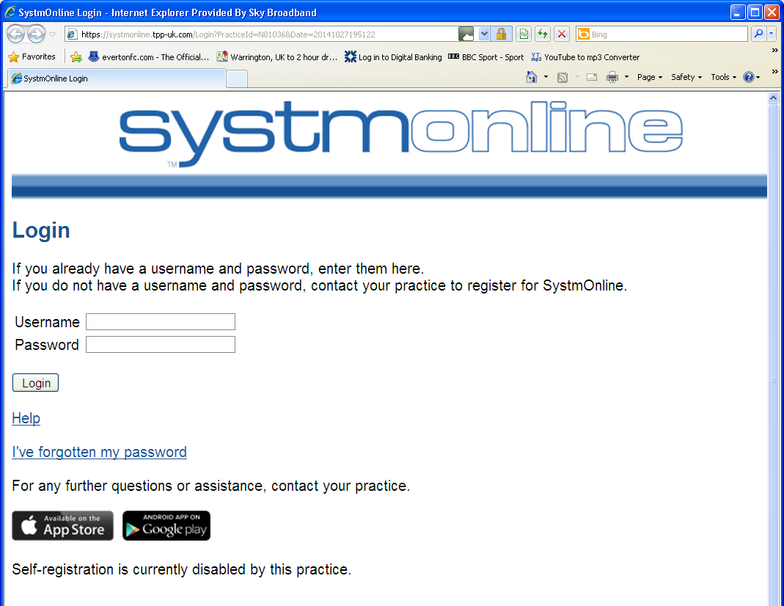

Once logged in you will see a list of options on the left hand side of the screen

- Book appointment
- My future appointments
- My past appointments
- Current prescriptions
- Change Pharmacy
- Change contact details
- Grant additional Access
- Ask a question
- Questionnaires
- View Test Results
- Help
- Log out

To request your REPEAT medication click on CURRENT PRESCRIPTIONS
A list of your repeat medication will appear
Tick the box next to the medication you require and press the REQUEST MEDICATION button
If you find the tick box unavailable as below this is because your GP needs to review your medication.

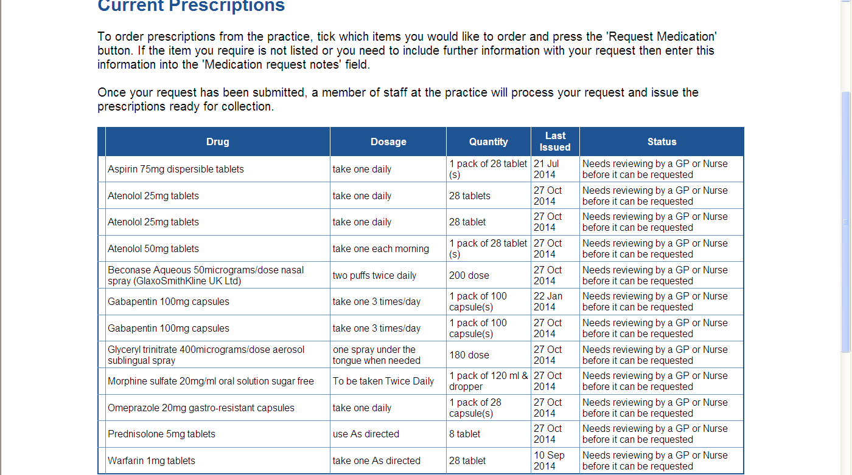

Simply type in the medication(s) you require in the box below MEDICATION REQUEST NOTES

Next click REQUEST MEDICATION

If you require an item that is not listed in your repeat list please use ASK A QUESTION and type the item you require

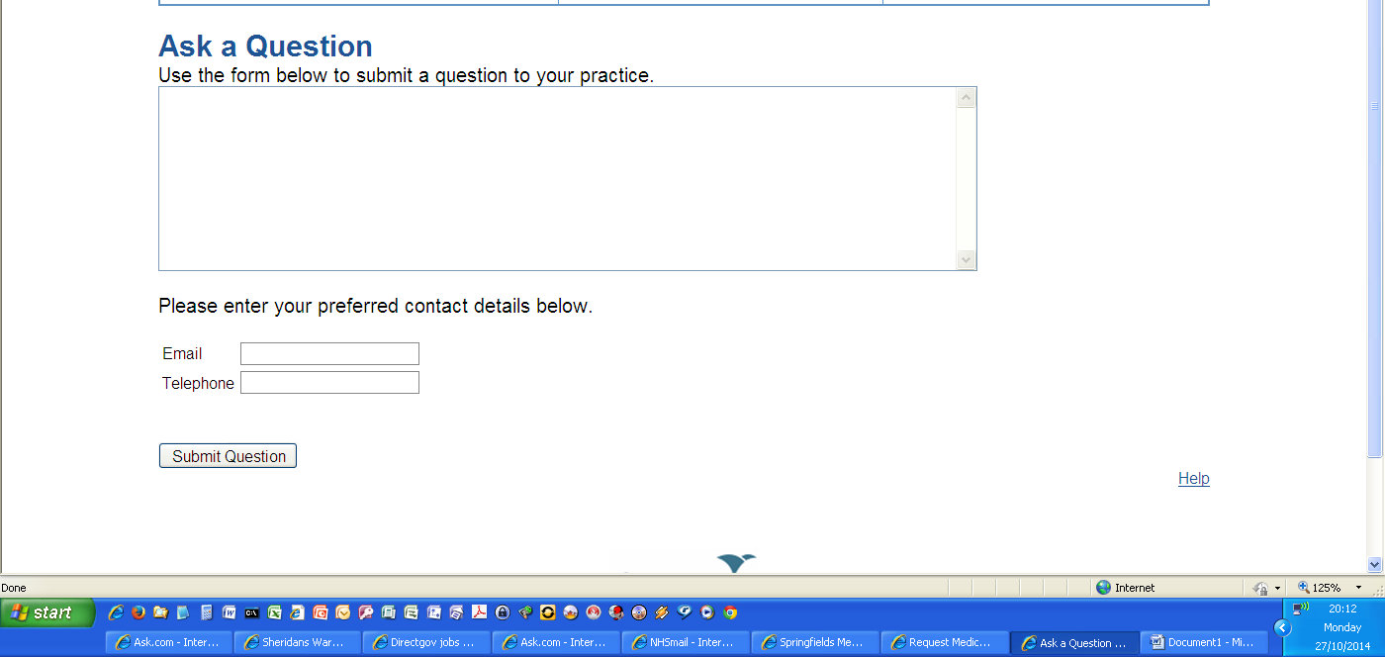

Enter either your e-mail address or telephone number and click SUBMIT QUESTION
The surgery will be able to process your prescription request from this link

